Assignment 1: PVCM-PVD Overview

Take screenshots of each query and its output and document all findings in a Word file. (Please DO NOT execute any DDL on any of the schemas)

PVCM URL: https://pvcm-62x-siab-bqa.rxlogix.com/
Stage user name: PVCM_PVD_STAGE_51_FORMAL
DB Details: 10.100.22.212:1521/ PVITEST
1. Find schema name of given users:
a.) Mart User
b.) PVR User
c.) Service User
select * from pvr_etl_constants where etl_key like '%USER%';
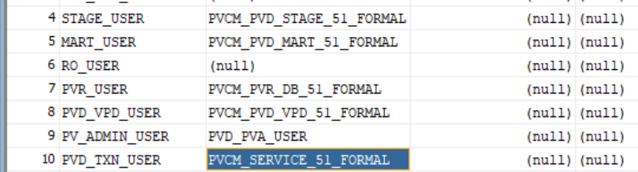
2. Create one spontaneous and one study case in PVCM, filling in as many fields as possible.
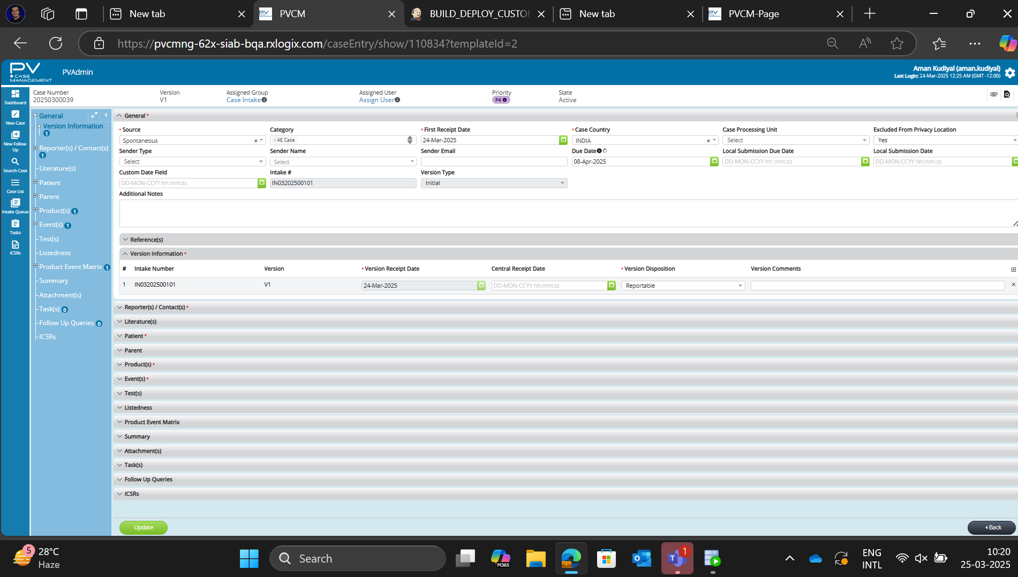
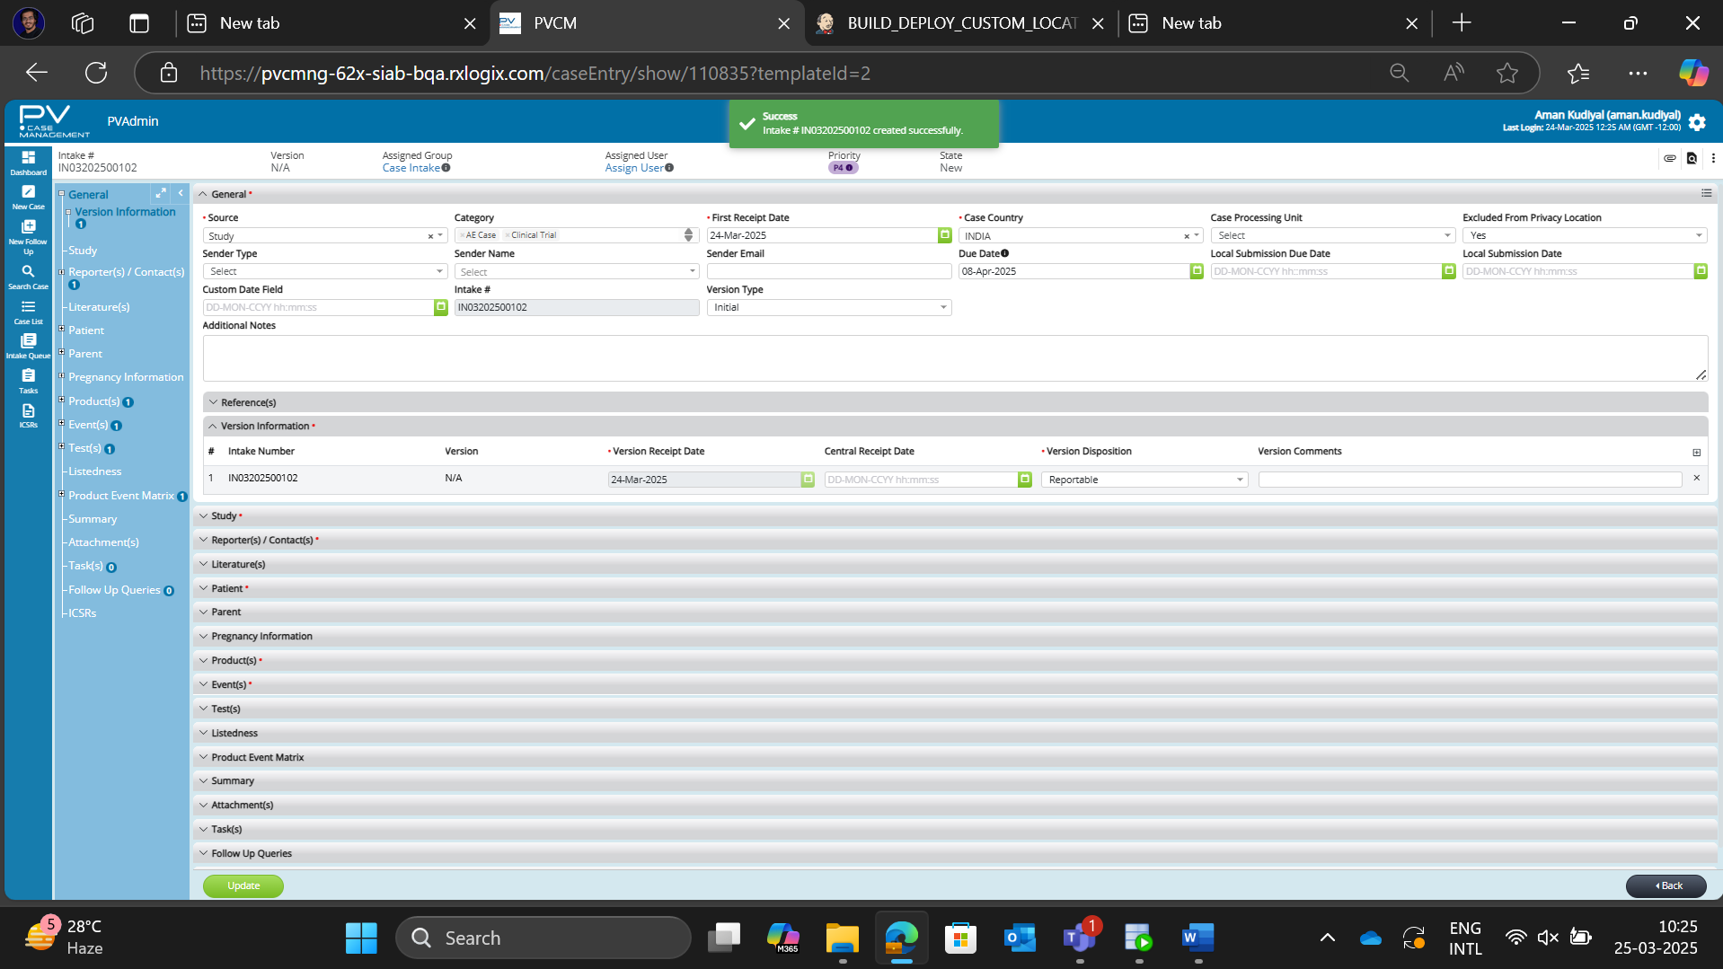

3. Check the total time taken by the case to be saved in PVCM service schema. (Tip: Refer to the logging table for case save details.)
select * from json_data_log where case_id=110834;
3 sec to accept and 4 sec for registering new case
4. Verify the data of following sections in PVCM service schema:(Attach screenshots of the case data from both the PVCM UI and the DB end.)
a.) Product
select * from c_prod_identification where case_id=110836;
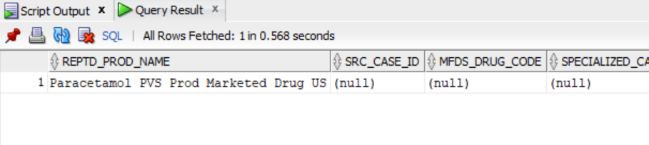
b.) Event
select * from C_AE_IDENTIFICATION where case_id=110836;
c.) Product-Event Matrix
select * from C_PROD_AE_MATRIX where case_id=110836
d.) Patient
select * from C_PATIENT_CHARACTERISTICS where case_id=110836
e.) Parent
select * from C_PARENT_CHARACTERISTICS where case_id=110836
f.) Tests
select * from C_TESTS where case_id=110836
g.) Reporter
select * from C_SOURCE where case_id=110836
h.) Patient Death Detail
select * from C_DEATH_CAUSE where case_id=110836
since no death is reported
i.) Patient Medical History
select * from C_PATIENT_REL_MED_CONDN where case_id=110836
j.) Parent Past Drug History
select * from C_PARENT_REL_PROD_HISTORY where case_id=110836’
k.) Study (Only for study case)
select * from C_STUDY_IDENTIFICATION where case_id=110835
5. Verify if the data has been synced to PVD mart schema. Also, find the ETL_EXECUTION_ID, start time and end time of the ETL execution in which the case got processed.
select * from pvr_etl_log order by log_dt desc;
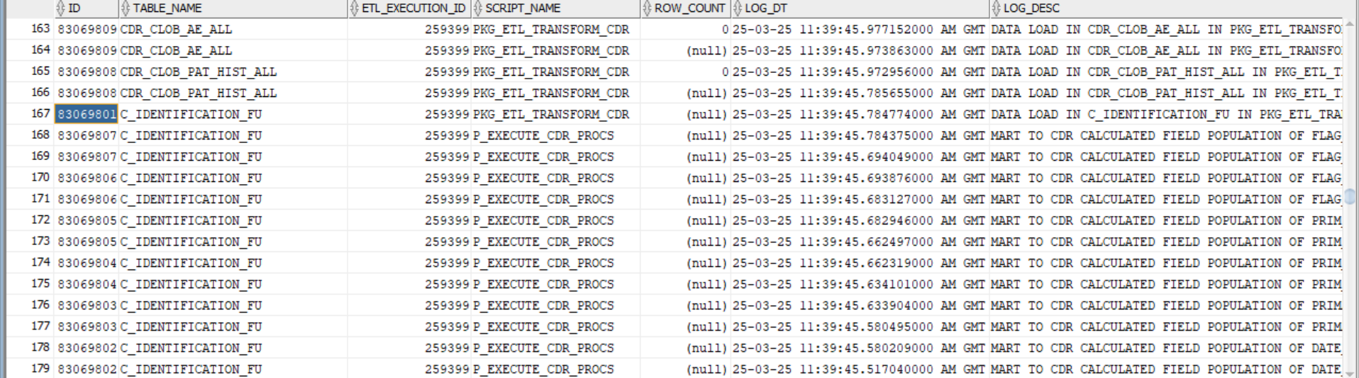
6. Configure one study and one product from PV Admin. Verify if the data has been synced in PVCM service.
Study:
Select * from studies where sponsor_study_number = '124816';

Product
Select * from PRODUCTS where PRODUCT_NAME = 'CHolera vaccine';
7. Add one more gender in the codelist using Import/Export functionality in PV Admin and verify same is displayed on PVCM UI. Create a case for the newly created gender and verify Gender fields data getting saved in PVCM Service and PVCM-PVD.
